Transversal seed cut of A. coahuilense: show cut of seed to observed internal structure that provided flotability.
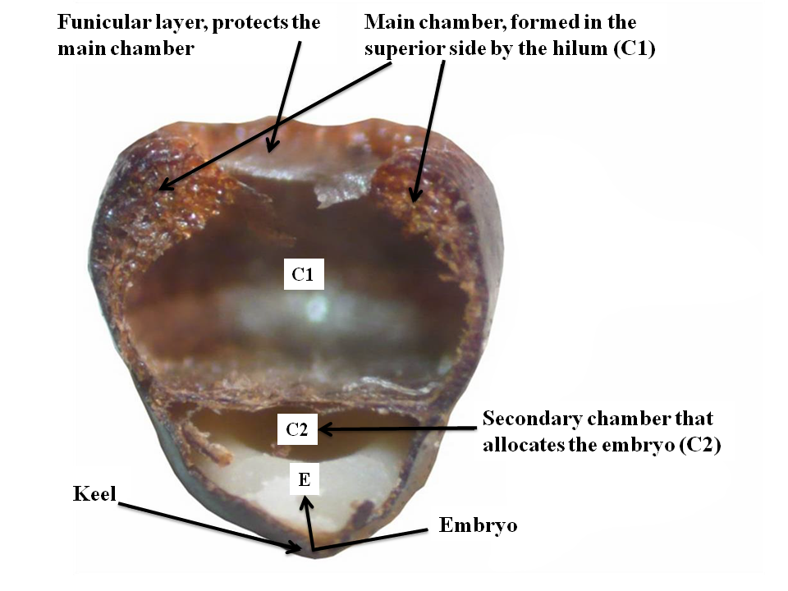
Figure 1. Seed cutting made by hand to observe the double chamber configuration in A. coahuilense seed, it is displayed: upper part the main chamber (C1) where the spongy tissue is found, while in the lower part of the seed is the embryo chamber (C2), the whitish structure is the endosperm and in the lower part of the endosperm is the region called the keel, where the embryo (E) is located and also part of the secondary chamber. Image provided by Jaime Sánchez.

Graph: determination of groups for buoyancy
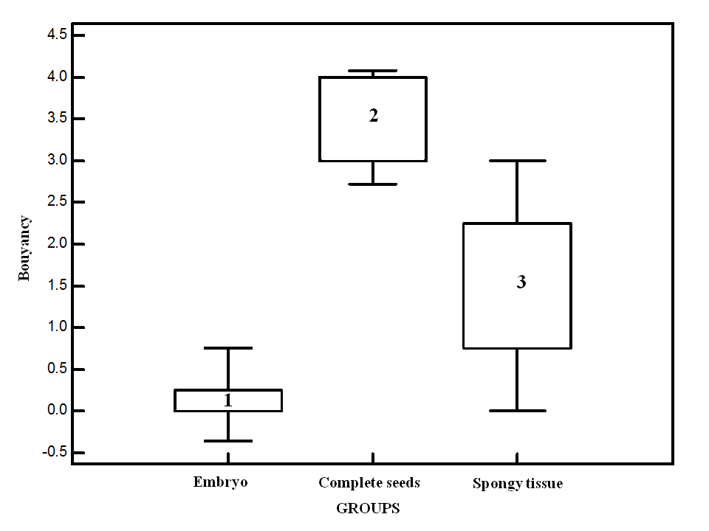
Figure 2. Tukey graphic displaying statistical median dispersion values for floatability of the different seed structures evaluated.

